Experiment No. 1

A) Create a java class called **student** with the following details as variables within it.

1. USN
2. Name
3. Branch
4. Phone

Write a java program to create n student objects and print the USN, Name, Branch and Phone of these objects with suitable headings.

**Source code:**

import java.util.*;

public class student {

String USN;

String Name;

String Branch;

long Phone;

void insert(String usn, String name, String branch, long phone) {

this.USN = usn;

this.Name= name;

this.Branch = branch;

this.Phone = phone;

}

void display() {

System.out.println(USN + " " + Name + " " + Branch + " " + Phone);

}

public static void main(String[] args) {

student s[];

s = new student[100];

Scanner in = new Scanner(System.in);

System.out.print("Enter no of students: ");

int n = in.nextInt();

for(int i=0;i<n;i++){

s[i] = new student();

}

for(int i=0;i<n;i++) {

System.out.println("Enter details:");

System.out.print("Enter USN:");

String usn = in.next();

System.out.print("Enter Name:");

String name = in.next();

System.out.print("Enter Branch:");

String branch = in.next();

System.out.print("Enter Phone:");

long phone = in.nextLong();

s[i].insert(usn, name, branch, phone);

}

for(int i=0;i<n;i++) {

s[i].display();

System.out.println("");

}

}

}

**Output:**

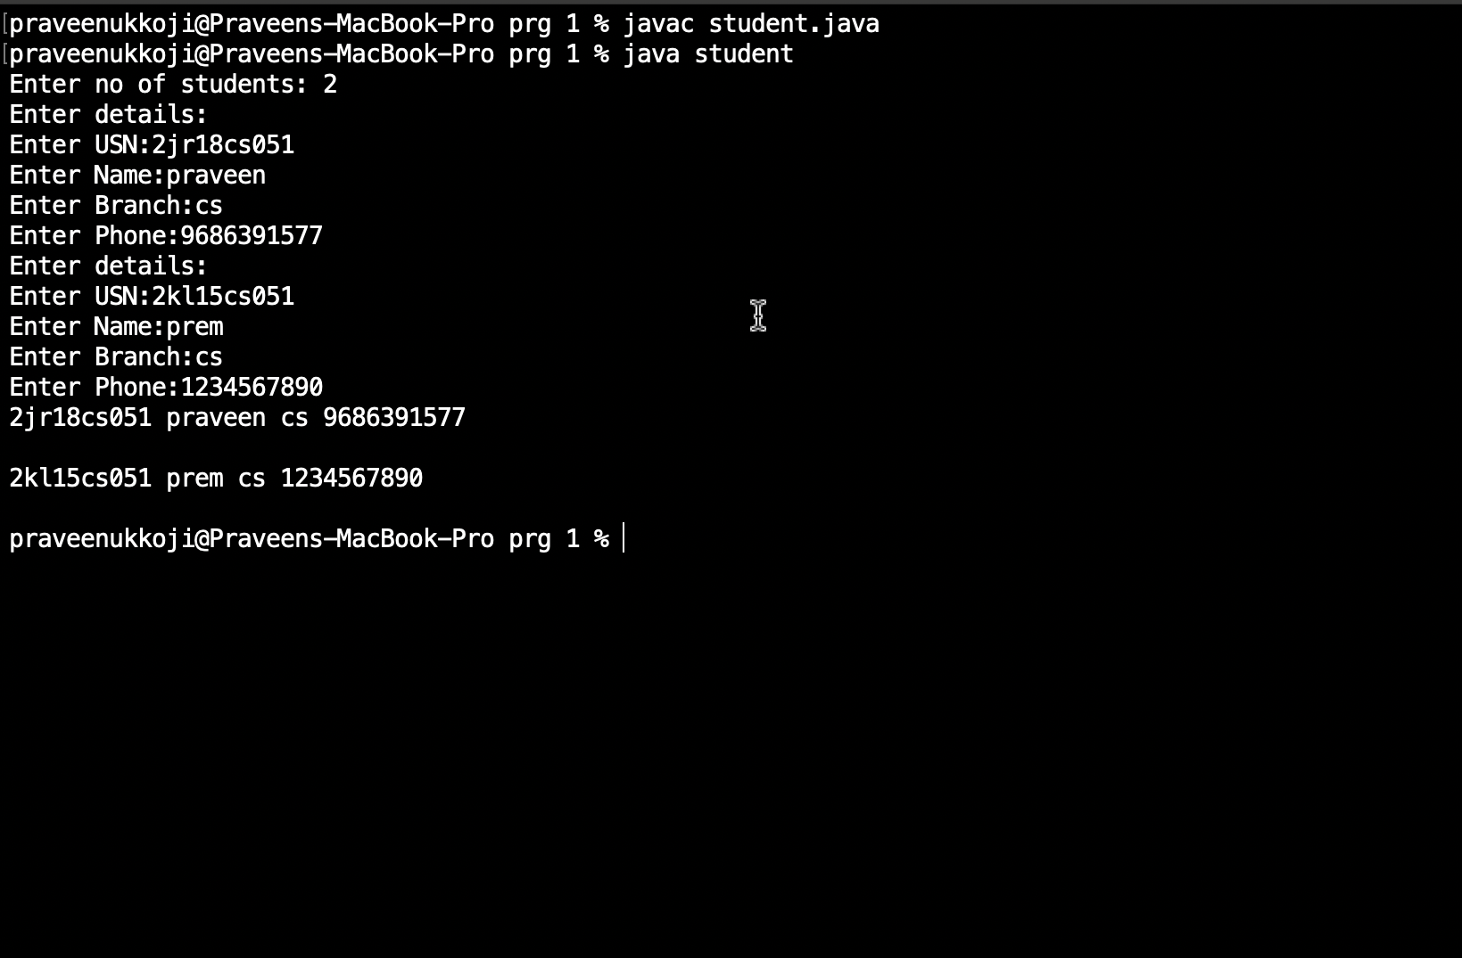

B) Write a java program to implement the stack using arrays. Write push(), pop() and display() methods to demonstrate its working.

**Source code:**

import java.util.*;

public class stack {

static int stack[], top = -1;

public static void main(String[] args) {

System.out.print("Enter Stack Size: ");

Scanner in = new Scanner(System.in);

int size = in.nextInt();

stack = new int[size];

System.out.println("\nOptions:\n1.PUSH\n2.POP\n3.DISPLAY\n4.EXIT");

System.out.print("Enter your Choice: ");

int choice = in.nextInt();

while(choice != 4)

{

if(choice == 1) {

System.out.print("\nEnter Element to push: ");

int element = in.nextInt();

if(top == size-1)

System.out.println("\nStack is full.");

else

stack[++top] = element;

}

else if(choice==2) {

if(top == -1)

System.out.println("\nStack is empty.");

else

System.out.println("\nPopped element is: "+ stack[top--]);

}

else if(choice==3) {

if(top == -1)

System.out.println("\nEmpty stack.");

else {

System.out.print("\nStack Elements are: ");

for(int i=top; i>=0 ;i--)

System.out.print(stack[i] + " ");

}

}

else

System.out.println("\nEnter Correct Choice \n");

System.out.println("\nOptions:\n1.PUSH\n2.POP\n3.DISPLAY\n4.EXIT");

System.out.print("Enter your Choice: ");

choice = in.nextInt();

}

in.close();

}

}

**Output:**

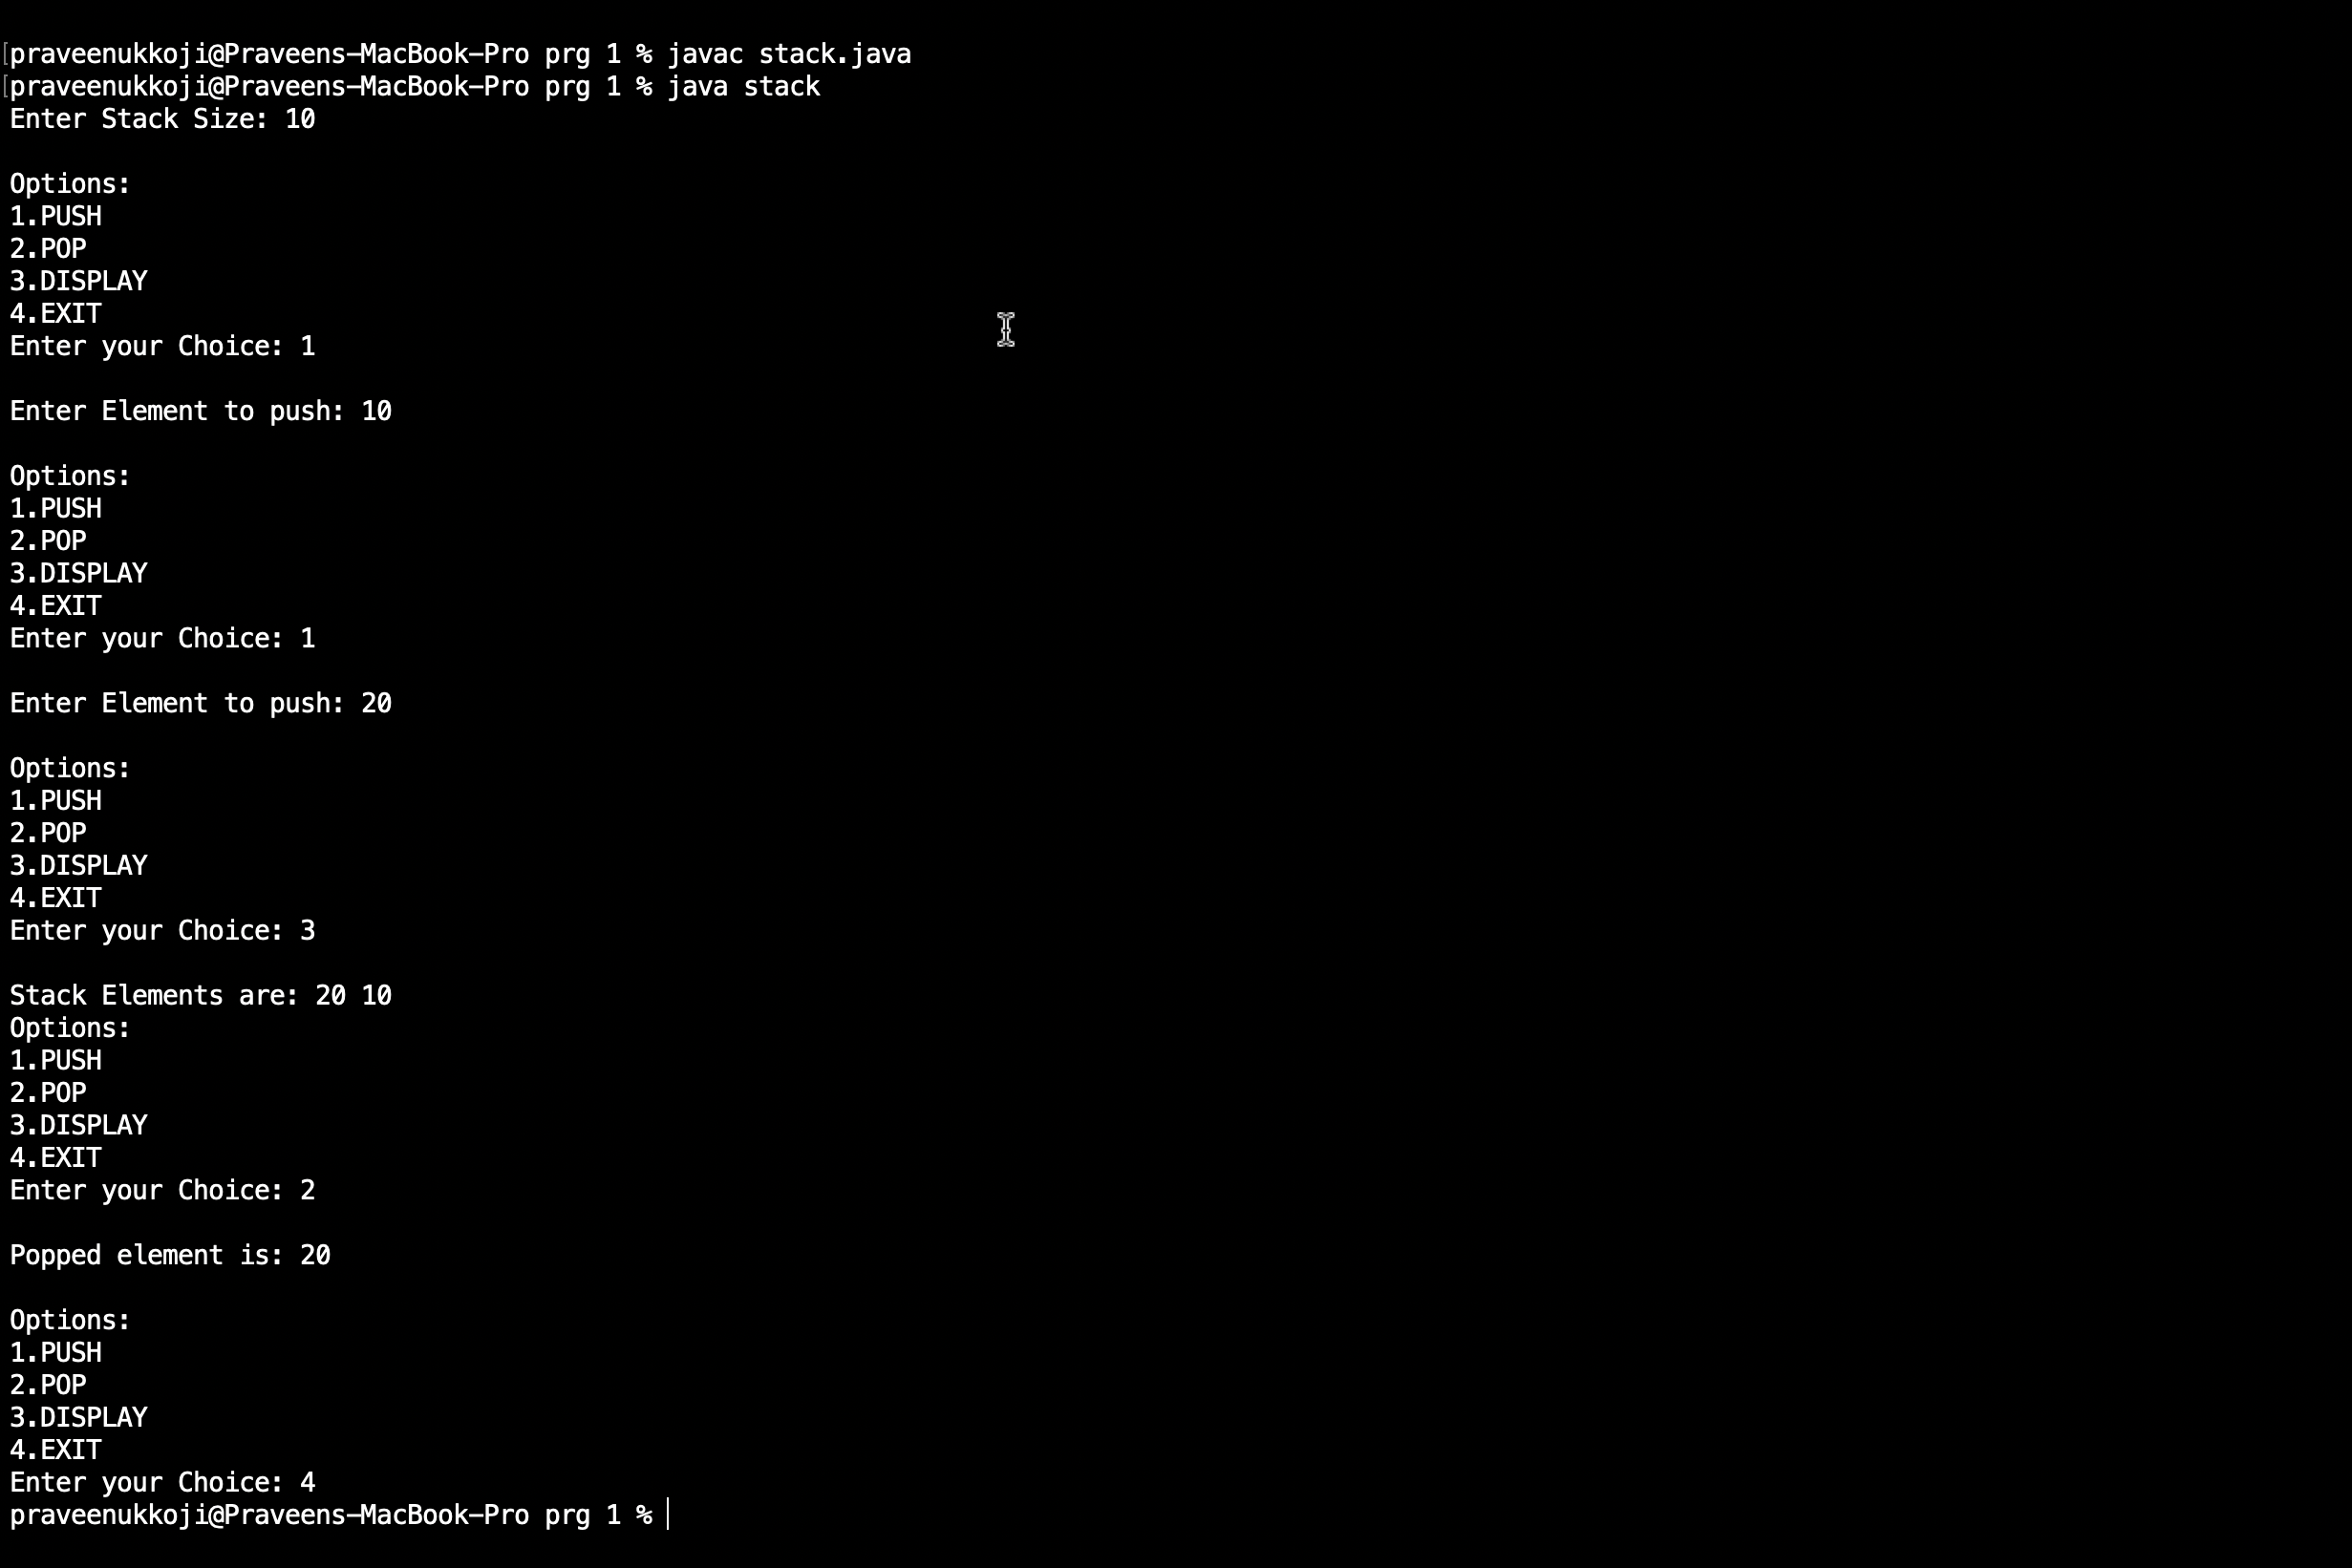

Experiment No. 2

A) Design a super class called **staff** with details as StaffId, Name, Phone, Salary.

Extend this class by writing three subclasses namely **Teaching**   
(domain, publications), **Technical** (skills) and **Contract** (period). Write a java program to read and display at least 3 staff objects of all three categoires.

**Source code:**

import java.util.*;

class Staff {

int StaffId;

String Phone;

int Salary;

String Name;

public Staff(int staffId, String phone, int salary, String name) {

this.StaffId = staffId;

this.Phone = phone;

this.Salary = salary;

this.Name = name;

}

void display() {

System.out.println("");

System.out.println("Staff Id: " + StaffId);

System.out.println("Phone: " + Phone);

System.out.println("Salary: " + Salary);

System.out.println("Name: " + Name);

}

}

class Teaching extends Staff {

String Domain;

int No_of_publications;

public Teaching(int staffId, String phone, int salary, String name, String domain, int no_of_publications) {

super(staffId, phone, salary, name);

this.Domain = domain;

this.No_of_publications = no_of_publications;

}

void TeachingDisplay() {

System.out.println("");

System.out.println("Teaching Staff Details:");

super.display();

System.out.println("Domain: " + Domain);

System.out.println("No_of_publications: " + No_of_publications);

}

}

class Technical extends Staff {

String Skills;

public Technical(int staffId, String phone, int salary, String name, String skill) {

super(staffId, phone, salary, name);

this.Skills = skill;

}

void TechnicalDisplay() {

System.out.println("");

System.out.println("Technical Staff Details:");

super.display();

System.out.println("Skills: " + Skills);

}

}

class Contract extends Staff {

int Period;

public Contract(int staffId, String phone, int salary, String name, int period) {

super(staffId, phone, salary, name);

this.Period = period;

}

void ContractDisplay() {

System.out.println("");

System.out.println("Contract Staff Details:");

super.display();

System.out.println("Period: " + Period + " years");

}

}

public class main_staff {

public static void main(String[] args) {

Teaching Te1 = new Teaching(11, "9987654341", 300000, "Praveen", "Cse", 10);

Teaching Te2 = new Teaching(12, "9987654341", 31500, "Pavya", "Mech", 11);

Teaching Te3 = new Teaching(13, "9987654341", 3000, "Pravin", "EE", 12);

Te1.TeachingDisplay();

Te2.TeachingDisplay();

Te3.TeachingDisplay();

Technical Tn1 = new Technical(11, "9987654341", 22000, "Pavya", "C");

Technical Tn2 = new Technical(12, "9987654341", 23000, "Pavya2", "java");

Technical Tn3 = new Technical(13, "9987654341", 23000, "Pavya3", "C++");

Tn1.TechnicalDisplay();

Tn2.TechnicalDisplay();

Tn3.TechnicalDisplay();

Contract C1 = new Contract(11, "9987654341", 35000, "Pavya1", 3);

Contract C2 = new Contract(12, "9987654341", 36000, "Pavya2", 2);

Contract C3 = new Contract(13, "9987654341", 37000, "Pavya3", 1);

C1.ContractDisplay();

C2.ContractDisplay();

C3.ContractDisplay();

}

}

**Output:**

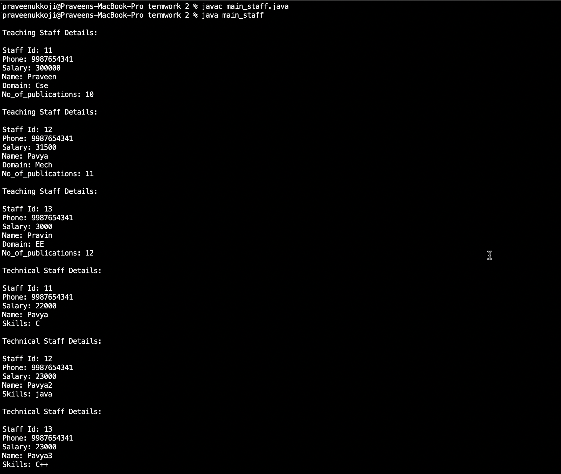

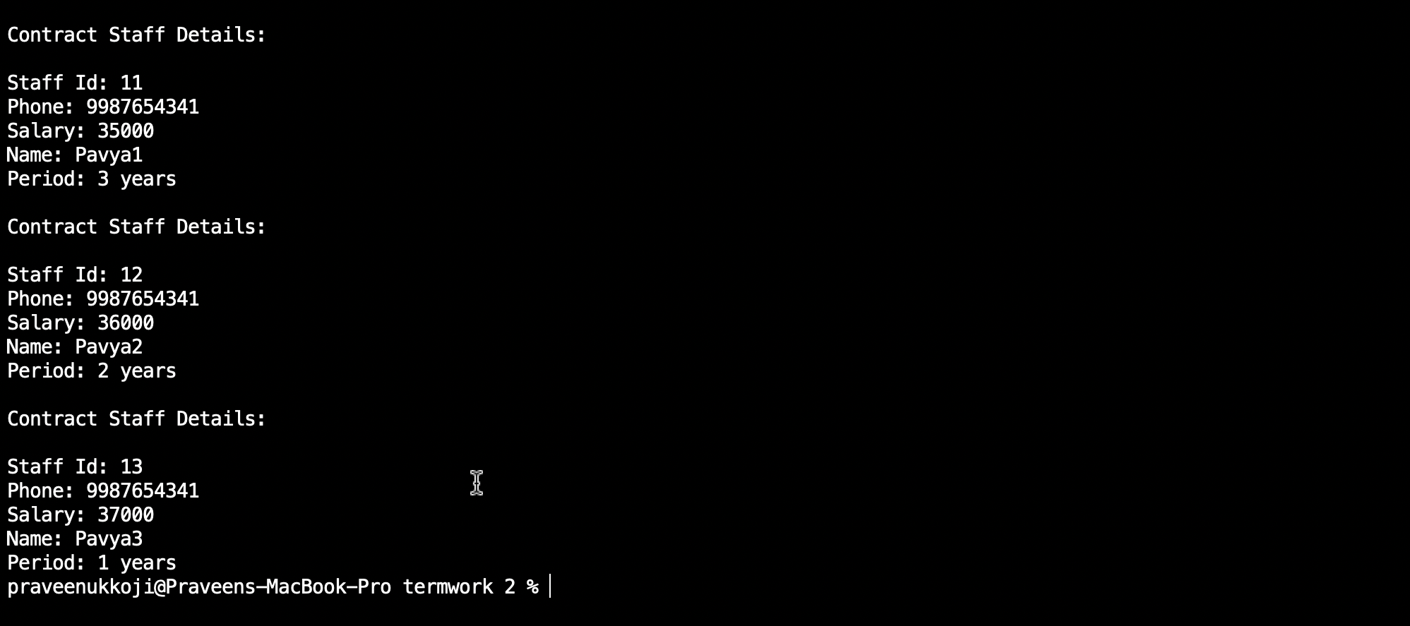

B) Write a java class called **Customer** to store their name and date_of_birth. The date_of_birth format should be dd/mm/yyyy. Write methods to read customer data as < name, dd/mm/yyy > and display < name, dd, mm, yyyy > using StringTokenizer class considering the delimete character as “/”.

**Source code:**

import java.util.Scanner;

import java.util.StringTokenizer;

public class customer {

String Name ;

String Date;

String Month;

String Year;

void read() {

Scanner in = new Scanner(System.in);

System.out.println("\nEnter Name and DOB in Name, DD/MM/YYYY Format: ");

String str = in.next();

StringTokenizer st = new StringTokenizer(str, "," + "/");

this.Name=st.nextToken();

this.Date=st.nextToken();

this.Month=st.nextToken();

this.Year=st.nextToken();

this.Name=this.Name.trim();

this.Date=this.Date.trim();

this.Month=this.Month.trim();

this.Year=this.Year.trim();

in.close();

}

void display() {

System.out.println("\nCustomer Details is: ");

System.out.println(this.Name + "," + this.Date + "," + this.Month + "," + this.Year);

}

public static void main(String[] args) {

customer c1 = new customer();

c1.read();

c1.display();

}

}

**Output:**

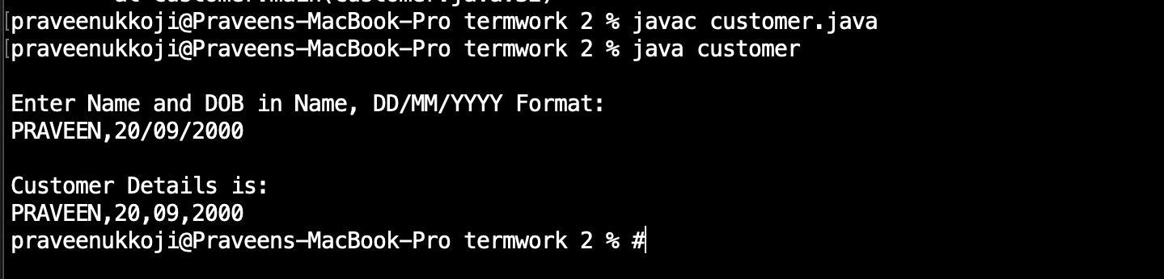

Experiment No. 3

A) Write a java program to read two integers a and b. Compute a/b and print, when b is not zero. Raise an excepetion when b is equal to zero.

**Source code:**

import java.util.Scanner;

public class Excep {

public static void main(String[] args) {

Scanner in = new Scanner(System.in);

int a,b,c;

System.out.println("Enter val of a and b: ");

a = in.nextInt();

b = in.nextInt();

try {

c = a/b;

System.out.println("c = " + c);

}catch(ArithmeticException e) {

System.out.println("Exception Encountered is "+ e);

}

in.close();

}

}

**Output :**

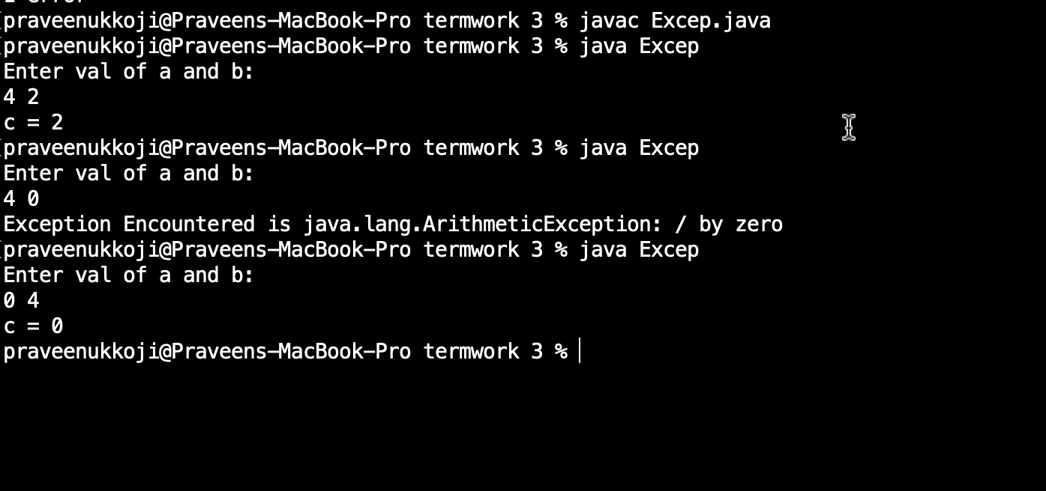

B) Write a java program that implements a multi-thread application that has three threads. First thread generates a random integer for every one second, second thread computes the square of the number and prints, third will print the value of cube of the number.

**Source code :**

import java.util.*;

class second implements Runnable

{

public int x;

public second (int x)

{

this.x=x;

}

public void run()

{

System.out.println("Second thread : Square of the number is: " + x * x);

}

}

class third implements Runnable

{

public int x;

public third(int x)

{

this.x=x;

}

public void run()

{

System.out.println("third thread : Cube of the number is: " + x * x * x);

System.out.println("");

}

}

class first extends Thread

{

public void run()

{

int num=0;

Random r=new Random();

try

{

for(int i=0;i<5;i++)

{

num=r.nextInt(100);

System.out.println("first thread generated number is: " + num);

Thread t2=new Thread (new second(num));

t2.start();

Thread t3=new Thread(new third(num));

t3.start();

Thread.sleep(1000);

}

}

catch(Exception e)

{

System.out.println(e.getMessage());

}

}

}

public class prg3b

{

public static void main(String args[])

{

first a=new first();

a.start();

}

}

**Output :**

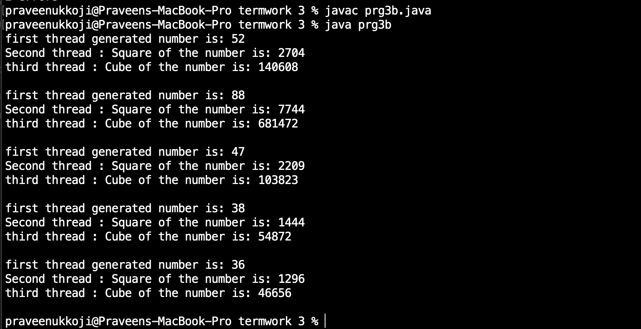

**Experiment No. 4**

Sort a given set of n integers elements using Quicksort method and compute its time complexity. Run the program for varied values of n>5000 and record the time taken to sort. Plot a graph of the time taken v/s n on graph sheet. The elements can be read from a file or can be generated using the random number generator. Demonstrate using java how the divide-and-conquer methods works along with its time complexity analysis worst case, average case and best case.

**Source code :**

import java.util.Scanner;

public class quick {

static int a[];

static void qsort(int left, int right)

{

if(left<right)

{

int p = partition(left, right);

qsort(left, p-1);

qsort(p+1, right);

}

}

static int partition(int low, int high)

{

int pivot = a[high];

int pindex=low;

for(int i=low;i<=high-1;i++)

{

if(a[i]<=pivot)

{

int temp = a[pindex];

a[pindex] = a[i];

a[i] = temp;

pindex++;

}

}

int temp = a[pindex];

a[pindex] = a[high];

a[high] = temp;

return pindex;

}

public static void main(String[] args) {

Scanner s = new Scanner(System.in);

int n, i;

System.out.println("Enter the no. of elements: ");

n = s.nextInt();

a = new int[n];

System.out.println("The Random Numbers are:");

for (i = 0; i < n; i++)

{

a[i] = (int) (Math.random() * 100);

System.out.print(a[i]+" ");

}

long startTime = System.nanoTime();

qsort(0, n-1);

long endTime = System.nanoTime();

long duration = (endTime - startTime);

System.out.println("\nThe Sorted Numbers are: ");

for (i = 0; i < n; i++) {

System.out.print(a[i] +" ");

}

System.out.println("\nTime taken is: "+ duration/1000 + " microseconds" );

}

}

**Output :**

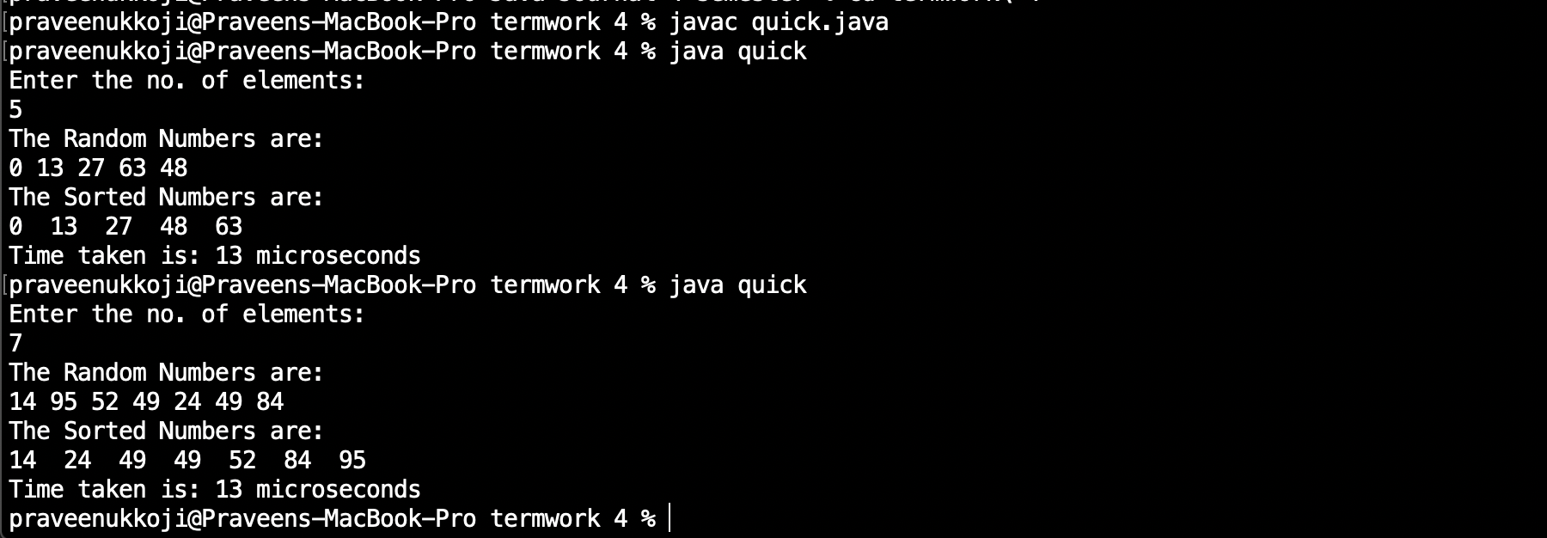

**Experiment No. 5**

Sort a given set of n integers elements using Mergesort method and compute its time complexity. Run the program for varied values of n>5000 and record the time taken to sort. Plot a graph of the time taken v/s n on graph sheet. The elements can be read from a file or can be generated using the random number generator. Demonstrate using java how the divide-and-conquer methods works along with its time complexity analysis worst case, average case and best case.

**Source code :**

import java.util.Random;

import java.util.Scanner;

public class mergesort{

static int max=10000;

void merge( int[] array,int low, int mid,int high)

{

int i=low;

int j=mid+1;

int k=low;

int[]resarray;

resarray=new int[max];

while(i<=mid&&j<=high)

{

if(array[i]<array[j])

{

resarray[k]=array[i];

i++;

k++;

}

else

{

resarray[k]=array[j];

j++;

k++;

}

}

while(i<=mid)

resarray[k++]=array[i++];

while(j<=high)

resarray[k++]=array[j++];

for(int m=low;m<=high;m++)

array[m]=resarray[m];

}

void sort( int[] array,int low,int high)

{

if(low<high)

{

int mid=(low+high)/2;

sort(array,low,mid);

sort(array,mid+1,high);

merge(array,low,mid,high);

}

}

public static void main(String[] args) {

int[] array;

int i;

System.out.println("Enter the array size");

Scanner sc =new Scanner(System.in);

int n=sc.nextInt();

array= new int[max];

Random generator=new Random();

for( i=0;i<n;i++)

array[i]=generator.nextInt(20);

System.out.println("Array before sorting: ");

for( i=0;i<n;i++)

System.out.print(array[i]+" ");

System.out.println("");

long startTime=System.nanoTime();

mergesort m=new mergesort();

m.sort(array,0,n-1);

long stopTime=System.nanoTime();

long elapseTime=(stopTime-startTime);

System.out.println("Time taken to sort array is: "+elapseTime+" nano seconds.");

System.out.println("Sorted array is");

for( i=0;i<n;i++)

System.out.print(array[i]+" ");

System.out.println("");

}

}

**Output :**

